Lifejacket & Liferaft Safety Presentation
Tuesday 26th April 1.30pm – 4.00pm
NAFC Marine Centre
Scalloway
D H Marine Ltd are delighted to sponsor the above and warmly invite you to attend
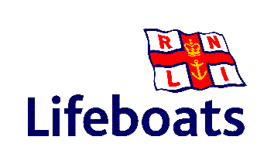
RNLI General Fishing Presentation
Mullion Floatation Garments & Lifejackets
Highlighting the importance of regular servicing & maintenance of PFD’s
including Waterside Demonstration
Ocean Safety Inflatable Life raft, EPIRBs and Personal Locator Beacons
Reviewing new Proposed Coding requirements for fishing vessels

Teas & Coffees served at 3.30pm
Knowledgeable staff on hand from all three companies so please take this opportunity to come along and discuss any queries you might have on your Lifesaving Requirements in general.
Supported by:
Shetland Shellfish Management Organisation Seafood Shetland
Shetland Fishermen’s Association Shetland Aquaculture
We look forward to seeing you on the day

